Training of National Judges in EU Competition Law

Justice Programme

Technical Report and
Financial Report

Version 1
December 2018

IMPORTANT NOTICE
What is the periodic report?
The final technical and financial report is the pre-condition for receiving payment and it must be submitted by the coordinator within 60 days after the end of the action.
The purpose of this report is to demonstrate how the action co-financed under the Justice Programme was implemented and how it contributed to the achievement of the objectives and priorities identified in the Call for proposals HT.5112 Training of national judges in EU competition Law.
The report is divided into a technical and financial report.
The technical report consists of:
- a narrative part on the work carried out and
- the Beneficiaries’ Evaluation Questionnaire
The financial report consists of:
- a summary financial statement
- Detailed budget
- a report on the use of resources

How to prepare and submit it?
The periodic report must be prepared (by all beneficiaries together) then be submitted by the coordinator in two version:
- 1 paper copy and
- 1 electronic version on CD or USB
You are invited to send the original copy of the final report including all the documents listed below to the following address:
By post or delivery service:
European Commission
DG Competition, Directorate R
Unit R2 – Finance and Internal Compliance
MADO 13/028, 1049 Brussels, Belgium

The paper and electronic copies of the final report must contain:
- Request for final payment
- Technical report
- Beneficiaries’ Evaluation Questionnaire
- Financial Report accompanied by the Detailed Final Budget
- Original or certified copy of duly signed list of participants for each day of attendance
- Original or certified copy of Participants Evaluation Questionnaires
- Final programme of the training event(s)
- Training materials (presentations, slides, brochures, etc.)
- The list of speakers
- Publications (if applicable)

The Commission reserves the right to request any additional information and documents in order to evaluate whether the costs claimed by the Beneficiary(ies) were declared in accordance with the Grant Agreement and the eligibility conditions.

Each beneficiary must provide the following documents for each cost category, upon request:
STAFF Costs [heading A.a)]
    - Employment contract (or equivalent document):
      - For permanent staff: existing contract with each staff member, clearly mentioning monthly salary and Secondment letter including description of tasks, reference to the project, duration, time allocated to the project, hourly/daily rate
      - For non-permanent staff specifically recruited for the project: specific contract linked to the project with indication of tasks, reference to the project, duration, time allocated to the project, hourly/daily rate
    - Payslips (or remuneration’s receipts)
    - Proof of payments (for no permanent staff)
    - Invoices – if the staff is not on the payroll with indication of tasks, reference to the project, duration, time allocated to the project, number of hours/days worked and hourly/daily rate.
    - Original (or certified) timesheets or equivalent documents showing the number of working days per month and the description of the tasks. The time records should be signed at least monthly by the employees (on paper or electronically in accordance with the Beneficiary’s time recording system) authorised and signed by the project manager or another manager
TRAVEL and SUBSISTENCE expenses for staff involved in the operation, for participants and for speakers [headings A.b); A.c)]
    - Copy of tickets and boarding passes
For travel by car, evidence of the corresponding rail fare and declaration of the expenses
    - Proof of reimbursement (if costs are not borne by the beneficiary)
    - Rooming list(s) clearly mentioning name of guests and number of nights spent
Unit costs for accommodation [headings A.b); A.c)] must be applied.
The original duly signed attendance lists and the hotel rooming list(s) will be sufficient supporting documents.
MEALS and REFRESHMENTS costs for staff involved in the operation as well as for participants, speakers and interpreters
Unit costs for meals and refreshments [headings A.d)] must be applied.
The original duly signed attendance lists and the hotel rooming list(s) will be sufficient supporting documents.
INTERPRETERS FEES [heading A.e)]
    - Copy of the contract(s) clearly mentioning languages translated, hours worked, date(s) of service
    - Invoice clearly mentioning languages translated, hours worked, date(s) of service, amount paid
    - Proof of payment
SPEAKER FEES [heading A.e)]
    - Copy of the contract(s) clearly mentioning work performed, hours worked (or forfeit established), date(s) of service, fees expected
    - Invoice clearly mentioning hours worked, date(s) of service, amount paid.
    - Proof of payment
EQUIPMENT AND IMMOVABLE PROPERTY (RENT PURCHASE) [heading A.f)]
    - Copy of the invoice. Please specify the usage rate and depreciation rule applied. You can only charge to the project the equipment's depreciated value. The direct link to the project implementation should also be presented.
    - Copy of the invoice of rental costs, clearly mentioning the item rent, the price per unit and the duration of the rent (in months/days). The direct link to the project implementation should also be described. If costs of rental of equipment are part of a service (room rental, hotel invoice), the cost should be clearly detectable.
    - Proof of payment

CONSUMABLES AND SUPPLIES [heading A.g)]

The costs of consumables and supplies are eligible, provided that they are identifiable and exclusively used for the purpose of the project.
General office supplies (pens, paper, folders, ink cartridges, electricity supply, telephone and postal services, Internet connection time, computer software, etc.) are considered as indirect costs [heading A.j)].
PUBLICATIONS and REPORTS [heading A.h)]
    - Copy of the invoices of publications costs, clearing mentioning the price per unit and the number of items published
    - Copy invoices of editing or proof-reading or translations of texts, clearly mentioning the rate per page and the pages analysed (if any)
    - Proof of payment
OTHER DIRECT COSTS [heading A.i)]
    - Copy of postage invoices clearly linked to the project
    - Proof of bank charges, clearly linked to the project
    - Accounting/audit invoices clearly linked to the project, specifying the hours/days worked and the rate per hours/day
    - Proof of payments

Training of National Judges in EU Competition Law

TECHNICAL REPORT

SUMMARY
TRAINING OF NATIONAL JUDGES IN EU COMPETITION LAW
Call reference number
Grant reference number
Title of the Action
Acronym
Name of the Beneficiary/
Coordinator
Co-Beneficiaries (for multi-beneficiaries grant agreement)  (Name & Country) | 1)  2)  Etc.
Legal Representative
(Name and Function)
Associate Partners (if any)  (Name & Country) | 1)  2)  Etc.
Thematic Priorities
Project website (if any)
Contact Details | Name:  Address:  Email:  Phone:
Duration of the Action  From the Start date (Article I.2.2 of the Grant Agreement) to the end of the Action | Start date:  End date:
Type and number of the event(s) / training activity(ies) | Conference Workshop  Case Law Study E-learning training course/Videoconference  Seminar Meeting  Study visit Symposium  Training Course Working Group  Other:
Date and Place of the event(s) | Date Place Organiser
Publications (if any)
Amendments (if any)
Grant amount | Amount of Total Eligible Costs:  Percentage of EU Grant:  Amount of EU Grant:
Expenditure incurred | Amount of Total Eligible Costs:  Percentage of EU Grant:  Amount of EU Grant:
Total Number of Participants
- By EU Member States
Austria |  | France |  | Malta
Belgium |  | Germany |  | The Netherlands
Bulgaria |  | Greece |  | Poland
Croatia |  | Hungary |  | Portugal
Cyprus |  | Ireland |  | Romania
Czech Republic |  | Italy |  | Slovakia
Denmark |  | Latvia |  | Slovenia
Estonia |  | Lithuania |  | Spain
Finland |  | Luxembourg |  | Sweden
 |  |  |  | United Kingdom
- By Candidate Countries
Albania |  | Montenegro

Technical REport
Context & overall objectives
Describe the context and overall objectives of the project, giving a general assessment of the results achieved in relation to the initial objectives and expected results stated in the Description of the Action (Annex 1 of the grant agreement).
EU competition law thematic topics
Describe the topics of EU competition law addressed throughout the duration of the project.
Work performed & main achievements
Describe the implemented activities and the main achievements.
Results & impacts
Describe the outcomes of the action and its (actual and expected) impact on target group, explaining how the results of the action correspond to the needs of the target group.
Key success & European dimension of the project results
Describe the key successes of the project, the European dimension of results and their contribution to the overall objectives of the Call for Proposals.
EU added value
Describe the European dimension of the project and the added value resulting from the EU’s support to the project compared to what could be achieved without EU funding.
What are the advantages and disadvantages of receiving funding from the European Commission compared to national funding for this type of projects?
Critical issues
Describe the problems and critical issues you have encountered (administrative, practical obstacles, difficulties with the partners, critical issues in the implementation, in reaching the target group, or in producing results, etc.) and the measures adopted to mitigate their impact on the project implementation.
Cooperation with the partnership (if applicable)
Describe how the co-beneficiary(ies) and associate partners participate in the project and what was their role in the implementation.
Project management & Staff involved
Report on changes to the overall project management concept (if any).
Sustainability, long-term impact & continuation
Report on any changes in your sustainability analysis/strategy (if any).
Describe the follow-up of the project after the EU financial support has ended, how the results will be used or further developed.
Describe the strategy to ensure sustainability of results and long-term impact. Comment on possible synergies/complementarities with other (EU funded) activities (if any).
Visibility of the EU funding
Explain how the visibility of the project was ensured: how did you show that the event(s) was funded by the European Commission.
Dissemination & communication activities
Report on the dissemination and communication activities undertaken in the framework of the project.
List only activities directly linked to the project.
 | Type of activity | Number
[Press release]
[Publications]
[Exhibition]
[Flyers]
[Training]
[Social media]
[Web-site]
[Communication campaign (e.g. radio, TV)]
[Brokerage event]
[Pitch event]
[Trade fair]
[Participation in activities organised jointly with other EU project(s)]
[Other]
Conclusions & Recommendations for the European Commission
Indicate lessons learned and other comments on the implementation of the project (positive and/or negative experience).
Indicate any recommendations and/or comments for the European Commission.

LIST OF Activities (Training events, Workshops, Seminars, Conferences, ETC.)
Organiser name |  |  | Training information |  |  |  | Attendees
 | Type |  |  | Place | Date | Duration  (days) | Total Number of participants | Geographical scope
 | [insert type, e.g. training, workshop, conference, event, etc.] |  |  |  |  |  |  | By EU Member States  Austria France Malta  Belgium Germany The Netherlands  Bulgaria Greece Poland  Croatia Hungary Portugal  Cyprus Ireland Romania  Czech Republic Italy Slovakia  Denmark* Latvia Slovenia  Estonia Lithuania Spain  Finland Luxembourg Sweden  United Kingdom*  By Candidate Countries  Albania Montenegro

Please add a row for each implemented activity

Beneficiaries' Evaluation Questionnaire

Please note that this template is a standard document, thus, if a section is not applicable to your specific project please indicate with 'N/A'. Where space is provided for additional information ensure that the changes are reflected in the Participants' Evaluation Questionnaire (PEQ). When the data required to answer these questions has to be gathered from the PEQ, the corresponding question in the PEQ is indicated (e.g. PEQ 1.a).

1. Number of participants
Using the data gathered from the participant identity boxes in the PEQ:
a(i) Please specify the number of judges who participated in the project:

a(ii) Please specify the number of prosecutors who participated in the project:

a(iii) Please specify the number of apprentice national judges who participated in the project:

a(iv) Please specify the number of judicial court staff who participated in the project:

2. Content and overall evaluation of the training
a) Based upon the questionnaires issued to the participants, what percentage of the judicial staff noted a "minimal", "moderate" and "great" improvement in their knowledge of EU competition law topics and policies? (PEQ 1.b.)

Improvement | % of participants
Minimally
Moderately
Greatly

b) Based upon the questionnaires issued to the participants, what percentage of the judicial staff noted a "minimal", "moderate" and "great" improvement in their confidence in application/interpretation of EU competition law topics and policies? (PEQ 1.c.)

Improvement | % of participants
Minimally
Moderately
Greatly

c) Based upon the questionnaire issued to the participants, what percentage of the judicial staff assessed as “poor”, “good” and “very good” the overall quality of the programme? (PEQ 1.d.)

Quality of the programme | % of participants
Poor
Good
Very good

3. Activities & Training methodologies
a) Please indicate which training methods were used, provided or established throughout the project and which methodologies have been considered most effective by the participants (PEQ 2.a.)

b) Using the results of the questionnaire issued to the participants, what percentage of the judicial staff deemed these tools/methodologies to be "useful" or "very useful" in the performance of the tasks in their line of work (PEQ 2.b.)

c) Where the sustainability of the training tools/methodologies is based upon the will of the participants to use the knowledge gained/tools-material provided following completion of the project, using the results of questionnaire issued to the participants, indicate what percentage of the judicial staff are "likely" to continually use the tools (PEQ 2.c.)

d) Using the results of the questionnaire issued to the participants, to what extent, if any, do the training tools/activities foster cooperation and continual dialogue in the field of EU competition law? (PEQ 2.d.)

Contribution of training tools/activities to the cooperation in the field of EU competition law | % of participants
Minimally
Moderately
Greatly

4. Organisation/Logistics/Administration Evaluation
a) Based upon the questionnaires issued to the participants, what percentage of the judicial staff deemed the administrative, organisation and structural implementation of the project to be "satisfactory" or "very satisfactory"? (PEQ 3.c(i))

b) If participants answered that they were "unsatisfied" what reasoning, if any, did they give? (PEQ 3.c(ii))

c) What suggestions, if any, did the participants give to improve the organisation, structure or administration of the implementation of this project? (PEQ 3.d.)

Template request for pre-financing

XX/XX/201X
European Commission
Directorate-General for Competition
Directorate R
Unit R2 – Finance and Internal Compliance
MADO 13/028
1049, Brussels - Belgium

Reference number: HT.XXXX, SI2.XXXX
Subject: Request for pre-financing

I hereby request a pre-financing payment under the Grant Agreement mentioned above.
The amount requested is XX,XXX.XX € (representing 50% of the maximum EU Commission contribution as specified in Art. I.3.).
The payment should be made to the following bank account:
Bank name
Address
Account N°
Iban
Swift/BIC code

Yours faithfully
Name of representative
Signature of legal representative

Template request for final payment

XX/XX/201X
European Commission
Directorate General for Competition
Directorate R
Unit R2 – Finance and Internal Compliance
MADO 13/028
1049, Brussels - Belgium

Reference number: HT.XXXX, SI2.XXXX
Subject: Request for final payment

In accordance with Art I.4. of the above-mentioned Grant Agreement, I hereby request a final payment of the balance to be paid by the EU Commission.
The amount requested is XX,XXX.XX €.
The payment should be made to the following bank account:
Bank name
Address
Account N°
Iban
Swift/BIC code

Yours faithfully
Name of representative
Signature of legal representative

Training of National Judges in EU Competition Law

FINANCIAL REPort

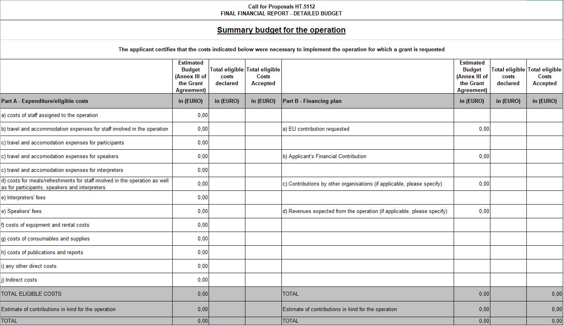
[The Detailed Budget shall be presented following the model of the grant agreement - Annex III. The table shall respect the headings and include a clear explanation of the means by which the amounts have been calculated]

Budget consumption — Use of resources (deviations)
Explain deviations from the budget planning (i.e. differences between actual and planned use of resources).
Include explanations on transfer of cost categories in the estimated budget (if applicable).

In case of activities organised by other beneficiaries in a multi-beneficiaries Grant Agreement.
Please indicate the number of participants referring to the target audience defined in the Call for Proposals (section 2).
Please note that the costs related to the participation of DK and UK are not eligible for reimbursement). See section 2.2 of the Call for Proposals.
See footnote 3.
* Please note that the costs related to the participation of DK and UK are not eligible for reimbursement). See section 2.2 of the Call for Proposals.
* See footnote above.

